Inserting an element in a sorted array that too in a sorted position.  
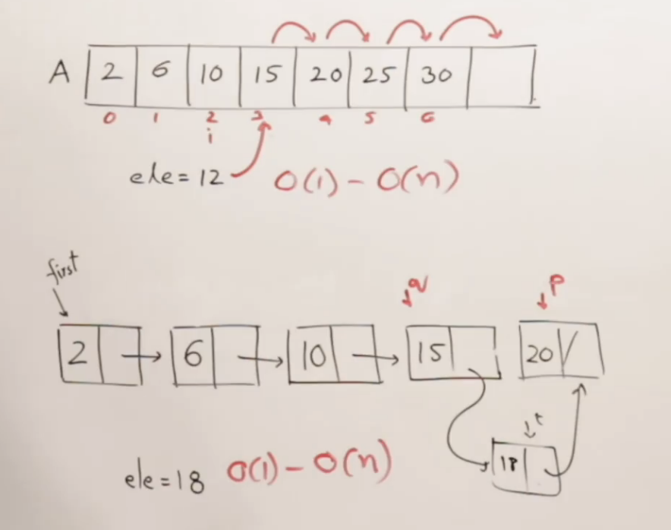

Swap the array elements, if the taken out element is greater than array element.

Every time, taking out an element from the right side and inserting them into a sorted position in the left side.

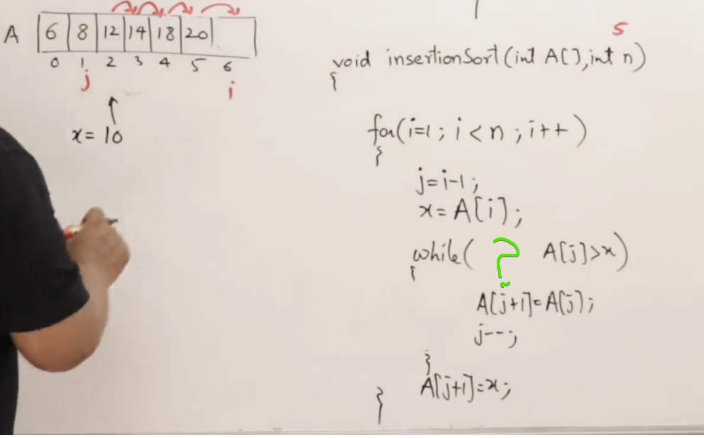

# **Adaptive**

By Nature, insertion sort takes minimum time for an already sorted array.

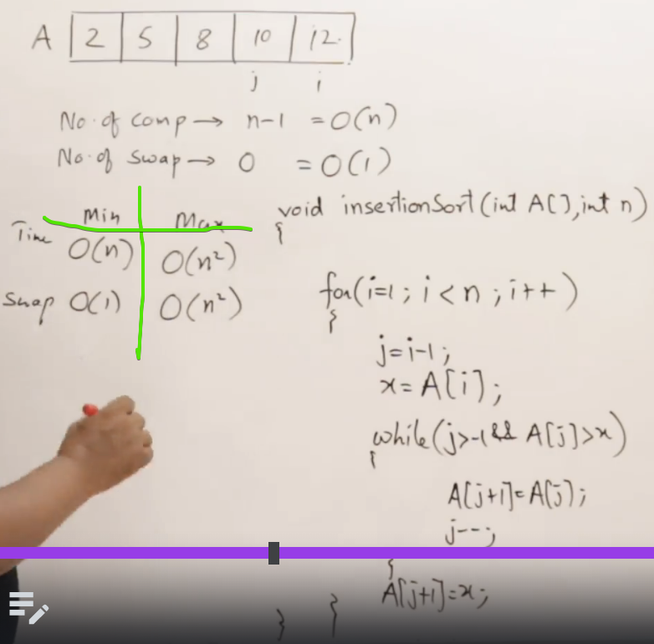

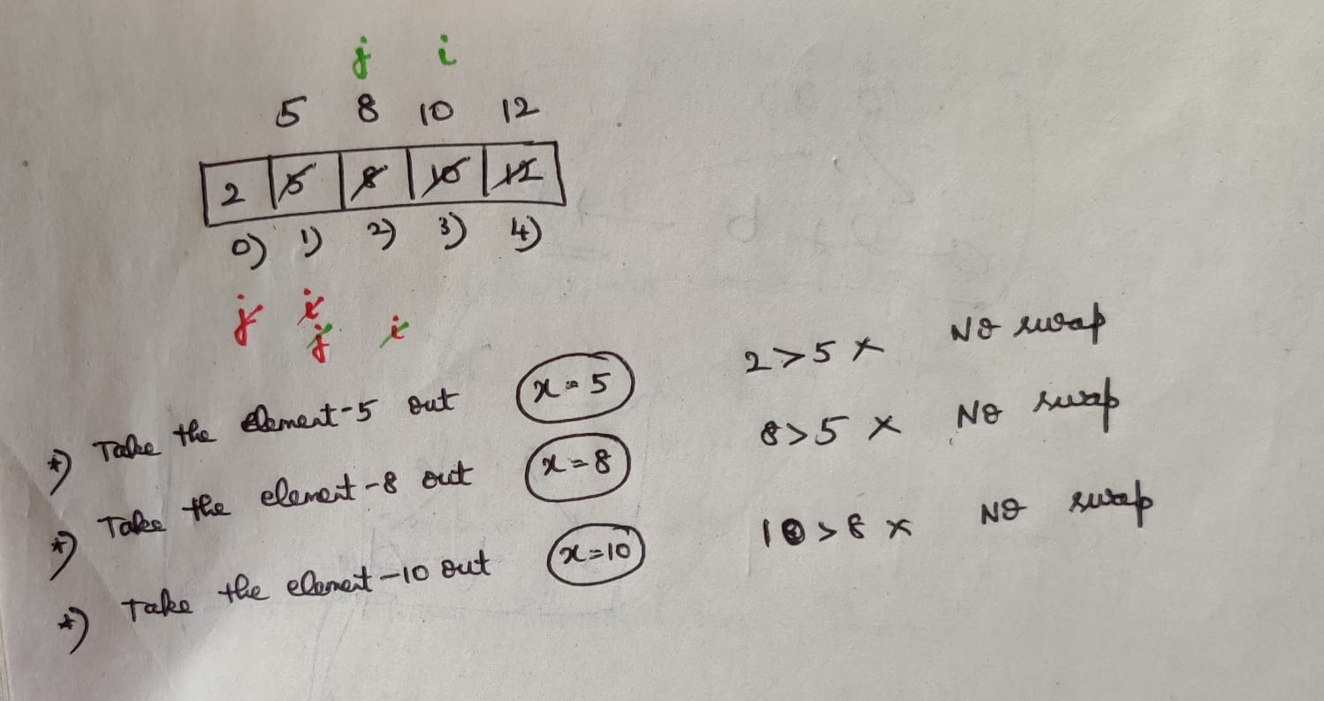

# **Program**

Though the program is in forward pass, always view the program from the reverse.

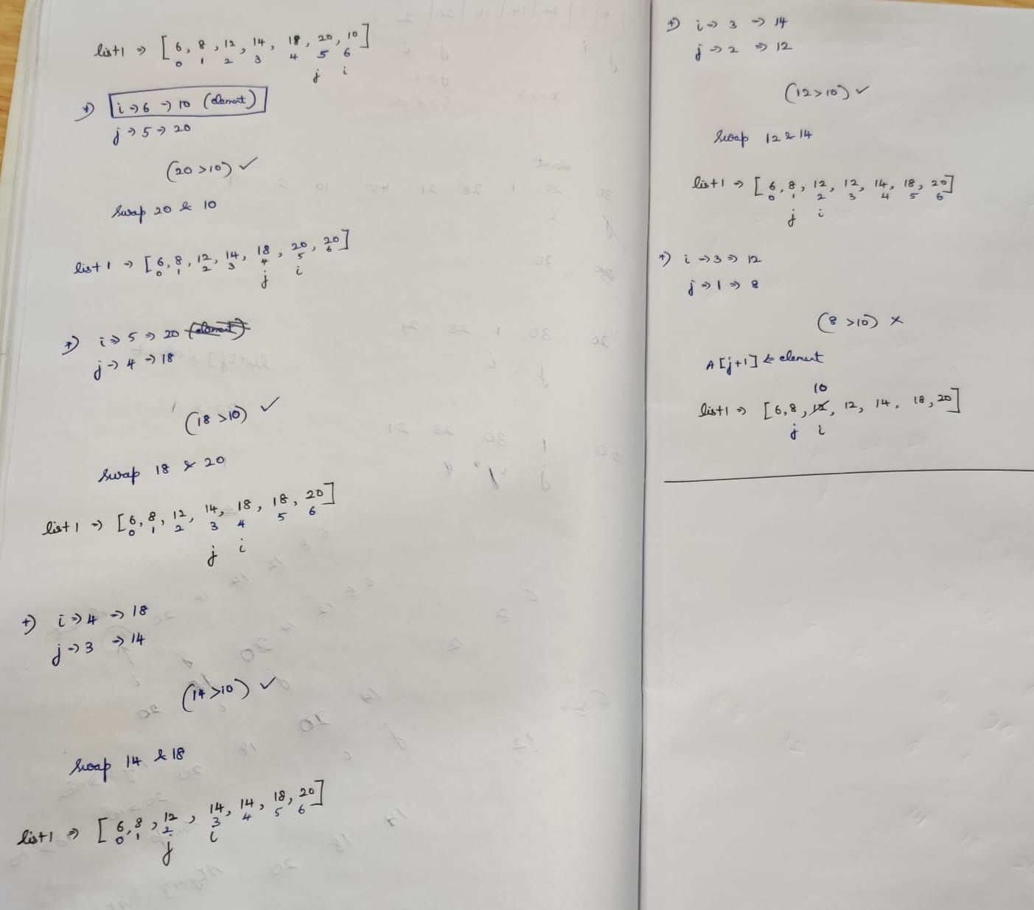

# **Key Points**

🡪 After every pass, will not get any useful element unlike Bubble sort.  
🡪 Linked List implementation is use-ful since we don’t want to shift the elements.

# **Difference**

